**ME 354**

Torsion Lab Write-Up

Konsta Jaske

Section AB

# Numerical Analysis

This lab involves experimentally and theoretically investigating the plastic yielding response of slender rod specimens of two different metals, 6061-T6 aluminum and A36 steel. This was accomplished by testing two specimens of each material in a Technovate torsion testing setup. Each specimen was clamped to axially aligned drill chucks at each end and subjected to a fixed sequence of rotations at the bottom chuck until failure. Initially each specimen was twisted at 2⁰ intervals until 30⁰; the force at each rotation increment was recorded. From 30⁰ to 45⁰ each specimen was twisted at 5⁰ intervals and the force at each position was recorded. Continuing from the 45⁰ orientation four more measurements at intervals of 45⁰ were recorded, then four more at 90⁰ intervals, then four more at 180⁰ intervals, then an indefinite number more at 360⁰ intervals until the specimen failed. The top chuck of the setup was attached to a wire carriage and attached to the wire carriage was a wire connecting a lever arm. This lever arm rotated around a pivot and the other end pushed down on a load cell when the twisting carriage pulled down on the arm. The torque applied to the specimen was calculated from the load cell readings and related to a moment balance about the pivot. This experimental data was compared to theoretical calculations obtained from tabulated material properties and plastic power hardening modeling.

## Torsion Analysis

### Experimental Setup

The angle of rotation of each specimen was measured using a troptometer. A schematic of the torsion setup and the force measurement configuration are shown in Figure 1.

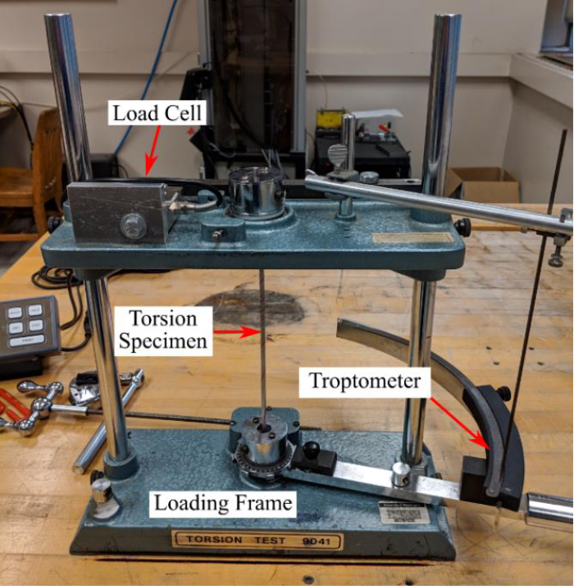

**Figure 1**: Image of the testing setup and load measurement scheme.

**Table 1**: Relevant dimensions of the torsion setup and samples.

|  |  |
| --- | --- |
| Bottom chuck to top chuck distance (m) | 0.18 |
| Wire carriage diameter (m) | 0.0523 |
| Lever arm length (m) | 0.213 |
| Pivot to connecting wire distance (m) | 0.085 |
| Specimen radius (m) | 0.00238 |

### Torsion Theory

Torsion leads to a state of nearly pure shear in the material and makes it possible to apply large strains prior to failure. Here we use an exponential hardening relationship to model the plastic deformation of the different rods under torsion. The torque in the specimen can be analyzed using the load cell readings and applying a moment balance about the lever arm pivot with the provided testing setup dimensions. The moment balance yields the equation

(Eq. 1)

where T is the torque in the specimen, F is the force experienced by the load cell in Newtons, and D is the diameter of the wire carriage in meters. The theoretical shear modulus and shear yield stress of each material were calculated from the equations

(Eq. 2)

(Eq. 3)

using the tabulated material properties shown in table 2. The maximum shear stress in each specimen was calculated from

(Eq. 4)

where r is the radius of the specimen and J is the second polar moment of area of the specimen as calculated from

(Eq. 5)

The maximum shear strain in each specimen was calculated from

(Eq. 6)

and the shear modulus of each specimen was approximated by using scipy’s linregress function to fit a linear regression to each specimen’s shear stress/strain data in the elastic region. The theoretical yield radius for every applied twist was found using

(Eq. 7)

The theoretical torque in each specimen was found using the power hardening relationships

, (Eq. 8)

, (Eq. 9)

(Eq. 10)

(Eq. 11)

(Eq. 12)

**Table 2**: Material properties of the 6061-T6 Aluminum and A36 Steel specimens used.

|  |  |  |
| --- | --- | --- |
|  | A36 Steel | 6061-T6 Aluminum |
| E (GPa) | 200 | 69 |
| ν | 0.26 | 0.33 |
| (MPa) | 250 | 275 |
| H (MPa) | 779 | 374 |
| n | 0.194 | 0.0417 |

# Experimental Results

## 6061-T6 Aluminum Analysis

The aluminum specimens underwent 33 and 35 revolutions before failure. Each specimen experienced the maximum amount of torque just prior to failure. The failure surface of each specimen was smooth and perpendicular to the axis of the specimen.

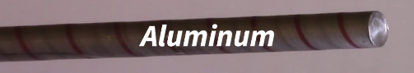

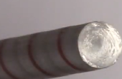

**Figure 2:** Aluminum specimen after failure

Both aluminum specimens experienced a dramatic, linear increase in torque in the elastic region. The twist angle interval of the elastic region for both specimens was very small relative to the twist angle interval in which the test was applied in entirety. The torque in each specimen with respect to the applied twist angle is plotted in figure 3.

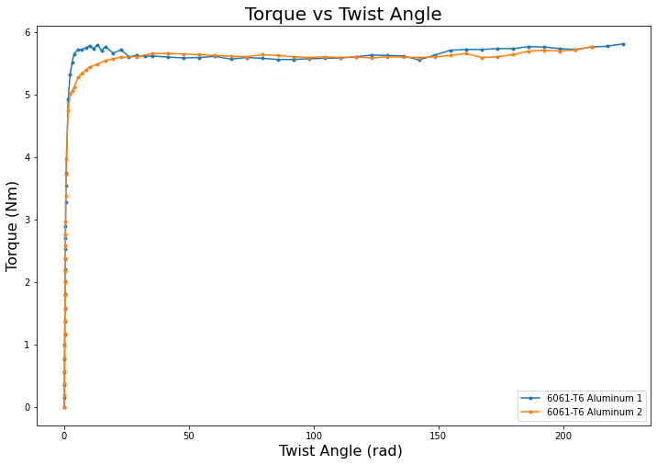

**Figure 3**: Aluminum torque vs twist angle results.

The max shear stress/strain plots of each specimen are shown in figures 4 and 5. The shear modulus linear regression fit for each dataset was calculated in the linear-elastic region. The average shear modulus of the two specimens is 20.25 GPa.

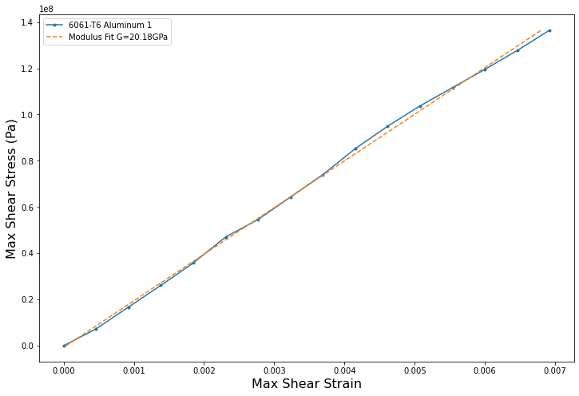

**Figure 4:** Shear modulus fit of aluminum specimen 1

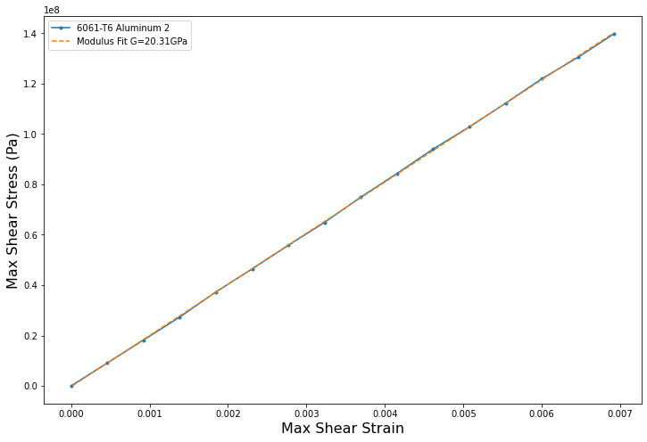

**Figure 5:** Shear modulus fit of aluminum specimen 2

Shown in figure 6 is the theoretical yield radius of aluminum specimen 1 with respect to the applied twist angle. As the specimen is twisted further the radius up to which the bar remains elastic decreases. At radii in the bar further than the yield radius the specimen plastically deforms. Theoretically, the specimen will start plastically deforming when the yield radius equals the bar radius; the intersection where this happens gives the twist angle at which the specimen begins to plastically deform.

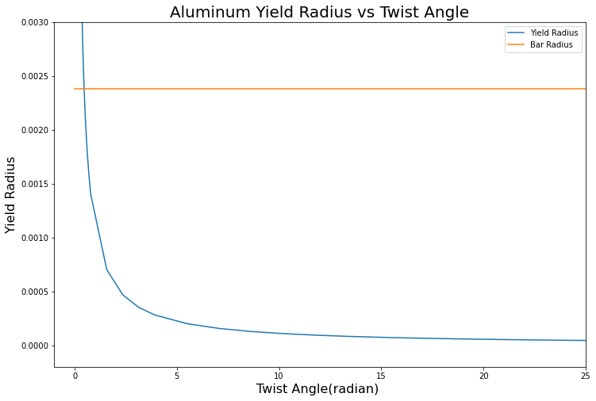

**Figure 6**: Aluminum yield radius vs twist angle results.

Figure 7 shows the experimental and theoretical torque vs twist angle results of aluminum specimen 1. The orange curve is the exponential hardening fit resulting from the given H and n values, while the green curve is the exponential hardening fit resulting from modified H and n values. The experimental data does not exhibit as much hardening as the theoretical results. It seems that changing the exponential hardening fit parameters does not change the shape of the curve but lifts it or lowers it along the torque axis.

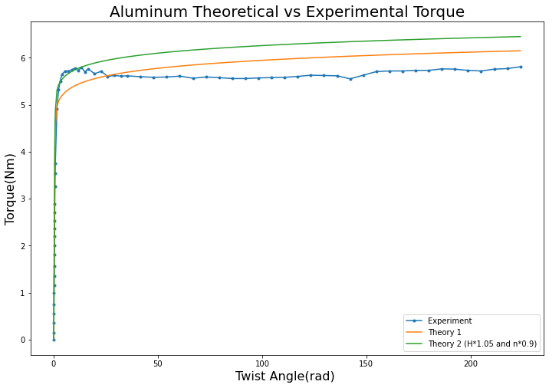

**Figure 7**: Aluminum theoretical vs experimental torque vs twist angle.

## A36 Steel Analysis

The steel specimens underwent 37 and 39 revolutions before failure. Each specimen experienced the maximum amount of torque just prior to failure. The failure surface of each specimen was smooth and perpendicular to the axis of the specimen.

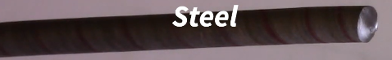

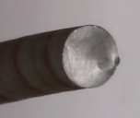

**Figure 6:** Steel specimen after failure

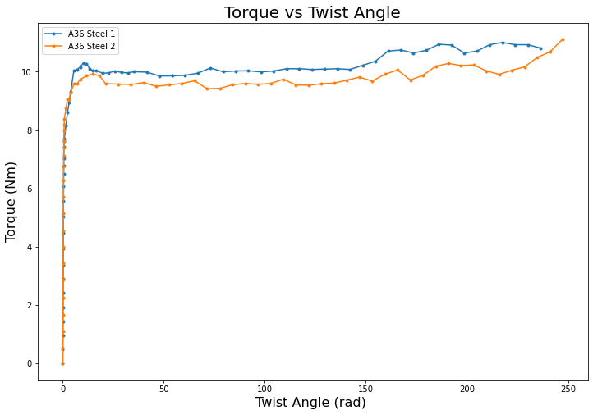

**Figure 7**: Steel torque vs twist angle results.

Both steel specimens experienced a dramatic, linear increase in torque in the elastic region. The twist angle interval of the elastic region for both specimens was very small relative to the twist angle interval in which the test was applied in entirety. The torque in each specimen with respect to the applied twist angle is plotted in figure 7.

The max shear stress/strain plots of each specimen are shown in figures 8 and 9. The shear modulus linear regression fit for each dataset was calculated in the linear-elastic region. The steel specimens exhibited a strong linear relationship in the elastic region; the regression fits averaged a regression value of 0.99978. The average shear modulus of the two specimens is 55.1 GPa.

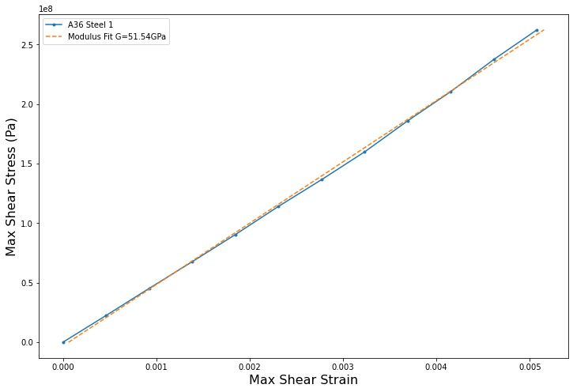

**Figure 8:** Shear modulus fit of steel specimen 1

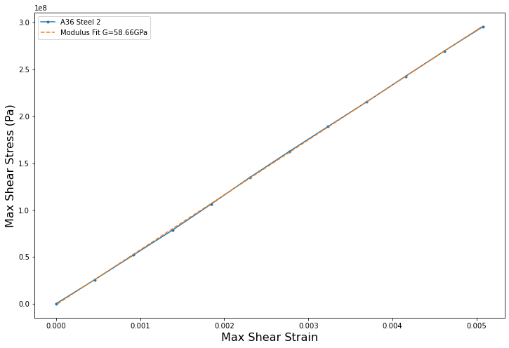

**Figure 9:** Shear modulus fit of steel specimen 2

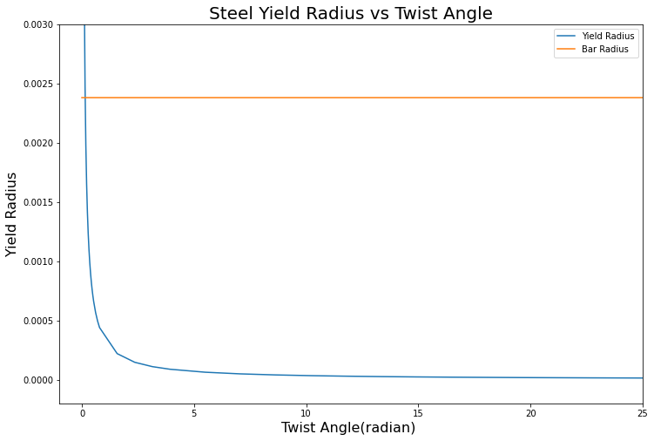

**Figure 10:** Steel yield radius vs twist angle results.

Shown in figure 6 is the theoretical yield radius of steel specimen 1 with respect to the applied twist angle. As the specimen is twisted further the radius up to which the bar remains elastic decreases. At radii in the bar further than the yield radius the specimen plastically deforms. Theoretically, the specimen will start plastically deforming when the yield radius equals the bar radius; the intersection where this happens gives the twist angle at which the specimen begins to plastically deform.

Figure 11 shows the experimental and theoretical torque vs twist angle results of steel specimen 1. The orange curve is the exponential hardening fit resulting from the given H and n values, while the green curve is the exponential hardening fit resulting from modified H and n values. The experimental data does not exhibit as much hardening as the theoretical results. It seems that changing the exponential hardening fit parameters does not drastically change the shape of the curve but lifts it or lowers it along the torque axis.

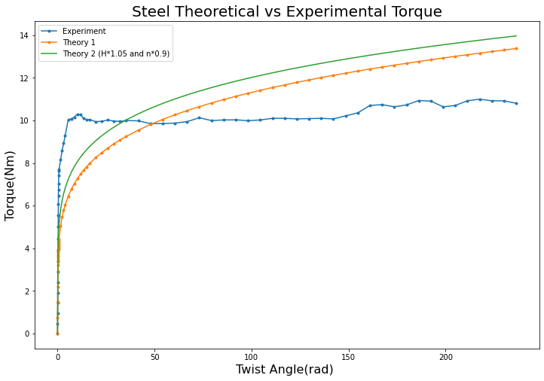

**Figure 11**: Steel theoretical vs experimental torque vs twist angle.

# Discussion

Both the aluminum and steel specimens underwent much less strain hardening than the power law hardening model predicted. The experimental results for each aluminum and steel specimen showed a sudden transition between the elastic and plastic states, while the power law hardening model predicts a smoother transition. While the power law hardening model predicts smooth strain hardening, the experimental results exhibited sporadic hardening and softening. Both specimens failed along a relatively smooth surface perpendicular to its axis. This indicates that aluminum and steel specimens failed in shear due to the applied torsion.

The method of holding the chuck in torsion after hearing the click and recording the load reading is not very accurate, as there is nothing stopping the tester from twisting the chuck further than the click and recording the load at a higher angle of twist than intended. The power law hardening model maintained a relatively similar shape of curve when the input parameters H and n were modified but moved vertically up and down, indicating the model primarily predicted a different yield torque with different inputs.

# Appendix